Connecting to a Windows Instance Using Remote Desktop

Step 1: You will first need to get the server credentials for your instance. This can be found on the “My Cloud” page within the Cloud Concierge site. Locate the IP, username, and password.
Note: You can also find this information within the confirmation email that you received from AskIBM Support when your instance completed provisioning. See example below:
Your instance's IP: 169.55.181.182
Expiration Date: Sep 7, 2017 1:40:00 PM after which the instance will get deleted.
Computer Name: adm121114919.demos.demoibm.com
Name in My Cloud: SoftLayer Migration Sandbox Windows 2016
Datacenter: tor01
Instance ID: 38803461
OS Username: administrator
OS Password: N8RAn7Hm
Use default RDP port 3333.

Step 2: On your Windows desktop, click the Start button and type “remote” in the search bar.
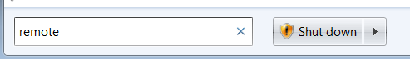

Step 3: Click on “Remote Desktop Connection” when the results appear.
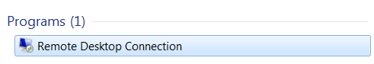

Step 4: Type the IP of your instance into the field and click Connect.
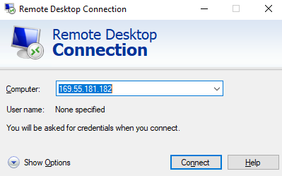
Note: Your instance may require a security port to access the instance. This information will show up in your ‘MyCloud’ section, and/or in the confirmation email. For example, if your port is “3333”, you will need to append it to your IP using a colon as seen below:
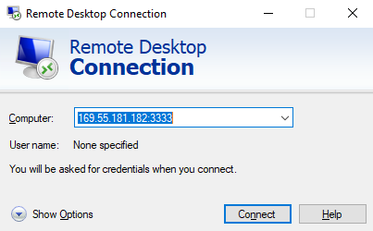

Step 5: You will now enter the credentials for your instance. Click Ok to logon to your instance.
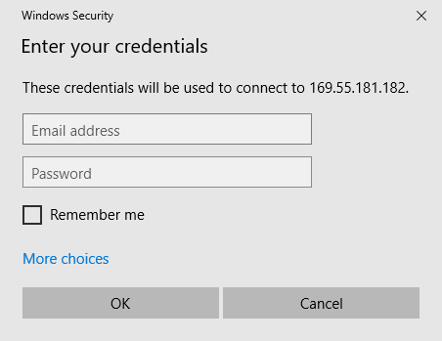

Step 6: Click Yes.
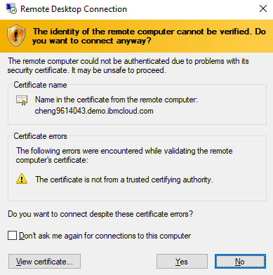

Step 6: The demo will now load, and you will be taken to the instance desktop.
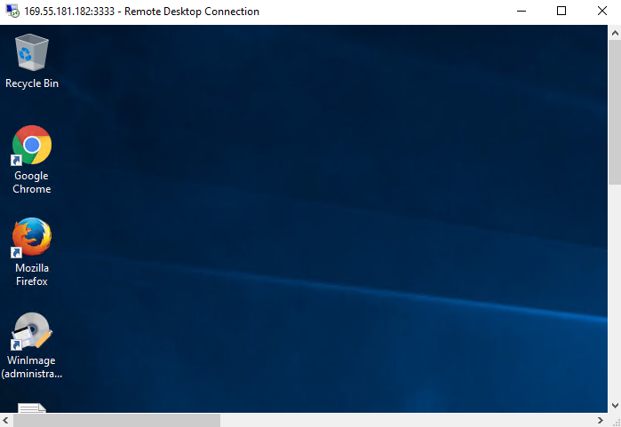

Troubleshooting Tips
Reminder: Remote Desktop Connection is a Windows utility. If you are on a Mac, please visit the Cloud Concierge support page for Mac instructions.
Startup Issues: Occasionally your instance will not fully load all services and prevent access to your instance. Reboot the instance in your ‘MyCloud’ page, wait 10 minutes, then try to log in again.
SoftLayer VPN: Some instances will require SoftLayer VPN security. If this is the case, then the IP Address will begin with a “10.x.x.x”. You will first need to login to a SoftLayer VPN session to access the instance. Please see the Cloud Concierge support site for instructions on connecting to SoftLayer, or click the link below if you have an existing account.
http://www.softlayer.com/VPN-Access

RDP Issues: Your firewall or network may be blocking RDP or the port needed for remote desktop. Follow the troubleshooting steps to resolve:
- If you provisioned a Private Instance, you will first need to connect to the SoftLayer VPN
- Be sure you can ping the IP address to ensure your computer can see the system.
- Ensure you are using the correct RDP port (check your My Cloud/email confirmation).
- Try using a public internet connection.
- If you are using IBM LEAP WiFi, turn your WiFi off and use an Ethernet cable.
- Check to see if a peer on the same network can ping and/or RDP to your system.
- Try a different computer on a different network, such as a home computer.
- On your PC, turn off Symantec or Windows firewall.
- Visit the My Cloud webpage, choose your system, obtain the Private IP of your system, VPN into SoftLayer, and return to Step 2.
Note: If you still need more help, you can reference the Network Troubleshooting guide on the Cloud Concierge Support website, or send an email to Cloud Concierge support at:
askibmst@ca.ibm.com

